

CSA15 – CLOUD COMPUTING AND BIG DATA ANALYTICS

ASSIGNMENT 1 – CO1

Design, Analyse and Validate a Cloud-Based Solution for Migrating a Legacy University Management System

CO1: Apply cloud computing technologies including hardware–software evolution, virtualization, web services, and service models to develop cloud-based solutions.

Field | Details | Field | Details
Student Name | G.Piyusha | Register Number | 192472377
Department / Section | CSE(AI) | Academic Year / Semester | 2024-2028
Faculty Name | Dr.R.Latha | Nature of Assignment | Individual
Duration | 1 Week | Total Marks | 50
Submission Date |  | Evaluation Date

MARK SHEET (Rubric-based evaluation)
Task | Title | Max | Awarded | Evidence / evaluation focus
1 | Introduce Cloud Computing | 3 |  | Definition; characteristics;  deployment models; scenario mapping
2 | Trace Evolution and Hardware Evolution | 3 |  | Timeline; hardware evolution; relevance to university
3 | Analyse Internet Software Evolution | 3 |  | Web/software evolution; SOA; APIs; scenario relevance
4 | Apply Server Virtualization | 5 |  | Hypervisor types; VM/container comparison; consolidation; limitations
5 | Apply Web Services | 4 |  | SOA and SOAP/REST; three university APIs; request/response examples
6 | Analyse IaaS, PaaS and SaaS | 5 |  | Responsibility layers; five-application mapping; comparison; providers
7 | Examine XaaS | 3 |  | Four or more variants; two justified choices; provider risks
8 | Design Cloud Solution | 5 |  | Labelled diagram;

 | Architecture |  |  | deployment/service models; scaling;  security; DR
9 | Hands-on Implementation and Documentation | 4 |  | Running VM/container; PaaS/SaaS; tests; actual screenshots
10 | Evaluate and Recommend Final Solution | 7 |  | Three-way comparison; 3-year costs; risks; phased roadmap
11 | Day-4 Design Challenge | 8 |  | Impact; evaluation; adaptation; evidence-based defence
 | TOTAL | 50 |  | Percentage :

EVIDENCE VERIFICATION CHECKLIST

Tasks | Evidence expected | Status (✓  / P / ✗ ) | Evaluator note
1–3 | Conceptual explanations, comparisons and relevant illustrations | ✓ | Explanations and relevant scenario mapping documented
4 | Virtualization calculations with  stated assumptions and peak-load caution | ✓ | Calculations present; practical capacity validation  recommended
5–7 | API examples, service responsibility table and justified XaaS choices | ✓ | Required conceptual evidence documented
8 | Labelled architecture diagram,  caption below figure and component justification | ✓ | Architecture documented;  sizing assumptions need testing
9 | Actual code, environment details, execution logs, API outputs and screenshots | P | Procedures provided; actual execution evidence not  established
10 | Cost assumptions, 3-year totals, risk controls and migration roadmap | ✓ | Estimates and rationale documented
11 | Day-4 changes, 10× load strategy, 99.9% target and 40-college isolation | ✓ | Design analysis documented; practical validation pending

IMPLEMENTATION EVIDENCE CHAIN

Evidence item | Status | Observation
Source code | ✓ | Flask REST API and Dockerfile provided in the proposed implementation
Virtualization | P | Docker container configuration documented; running-container evidence required
PaaS or SaaS | P | Managed web-service deployment procedure described; live deployment not verified
Functional test | P | Expected HTTP 200 response and JSON output documented; actual output required

Failure case | P | HTTP 404 test case documented; actual execution record required
Screenshots | P | Screenshot requirements identified; authentic screenshots need verification
Reproducibility | ✓ | Build commands, run commands, endpoints and expected results specified

OVERALL REMARKS

G.Piyusha  Student Signature | Faculty Signature | Program Director

MANDATORY SUBMISSION EVIDENCE CHECK
✓ = Present in documented answer; P = Partly present; ✗ = Missing / not satisfied

Task | Evidence expected | Status | Evaluator note
1 | Cloud definition, characteristics, deployment models and scenario mapping | ✓ | All conceptual requirements covered
2 | Evolution timeline, hardware  development and university relevance | ✓ | Well explained with relevant examples
3 | Internet software evolution, SOA and APIs | ✓ | Clear explanation and scenario relevance
4 | Hypervisors, VM/container  comparison and consolidation calculations | ✓ | Calculations included; peak-load limitations discussed
5 | SOAP/REST comparison and three university APIs | ✓ | API methods and request/response examples documented
6 | IaaS/PaaS/SaaS responsibility layers and application mapping | ✓ | All five applications categorized with justification
7 | XaaS variants and two justified selections | ✓ | Six variants explained; DBaaS and DRaaS recommended
8 | Labelled architecture, scaling, security and disaster recovery | ✓ | Design and component justifications documented
9 | Working container, PaaS/SaaS deployment, actual tests and screenshots | P | Code and procedures provided; actual  execution evidence requires verification
10 | Three-year cost comparison, risks and migration roadmap | ✓ | Cost assumptions, calculations and recommendations included
11 | Impact analysis, 10× load, 99.9% availability and tenant isolation | ✓ | Changed requirements evaluated; load-test evidence recommended

IMPLEMENTATION EVIDENCE CHAIN

Evidence item | Status | Observation
Source code | ✓ | Python Flask REST API and Dockerfile documented
Virtualization | P | Docker build and run procedures provided; execution screenshot required
PaaS or SaaS | P | Cloud deployment steps described; actual deployment confirmation required
Functional test | P | HTTP 200 and expected JSON response documented; actual

 |  | test output required
Failure case | P | HTTP 404 test case included; execution evidence required
Screenshots | P | Required screenshots identified but authenticity and completeness not verified
Reproducibility | ✓ | Installation, configuration, commands and testing steps documented
Interpretation | ✓ | Technical outcomes and implementation limitations explained
Code and report consistency | ✓ | Proposed API, Docker configuration and testing procedure are aligned

SUBMISSION CHECKLIST (Not Separately Marked)

Requirement | Status
All 11 tasks answered | ☒ Yes ☐ Partly ☐ No
Cloud concepts and comparisons explained | ☒ Yes ☐ Partly ☐ No
Virtualization calculations included | ☒ Yes ☐ Partly ☐ No
API examples and service models explained | ☒ Yes ☐ Partly ☐ No
Cloud architecture diagram included | ☒ Yes ☐ Partly ☐ No
Implementation and testing evidence provided | - Yes ☒ Partly ☐ No
Three-year cost analysis and roadmap included | ☒ Yes ☐ Partly ☐ No
Day-4 design challenge completed | ☒ Yes ☐ Partly ☐ No
Figures and screenshots included | - Yes ☒ Partly ☐ No
Table and figure numbering correct | - Yes ☒ Partly ☐ No
Viva recommended | ☒ Yes ☐ No

CSA15 – Cloud Computing and Big Data Analytics

ASSIGNMENT 1

CO1: Apply cloud computing technologies including hardware–software evolution, virtualization, web services, and service models to develop cloud-based solutions.

Assignment Title: Design, Analyse and Validate a Cloud-Based Solution for Migrating a Legacy University Management System (Total Marks – 50)

Duration: 1 week

Scenario – Smart Campus Cloud Migration
A multi-campus university currently runs its Student Information System, Learning Management System, Library System, Exam Portal and Email on ageing physical servers in a single on-premise data centre. Each application has its own dedicated server, which stays idle for most of the year but fails to cope during admissions, result publication and online-exam weeks.
The university's current environment is:
- 12 physical servers, average CPU utilisation of about 15%, with peaks above 95% during admissions and exams
- Approximately 25,000 students and 2,000 staff across 4 campuses
- Applications built as large monolithic programs, with no public interfaces for mobile apps or partner colleges
- High capital expenditure, slow procurement (6–8 weeks per server) and no disaster recovery site
As a cloud consultant, you must study how computing evolved to the cloud model, and then design a cloud-based solution that uses virtualization, web services and an appropriate mix of service models (IaaS, PaaS, SaaS and XaaS) for the university. All recommendations must be justified in terms of cost, scalability, availability and manageability.

Design Challenge:
On Day 4, the university announces that it will launch a mobile app and open student-record and fee-payment services to 40 affiliated colleges. Expected load is 10 times the current peak, with a requirement of 99.9% availability and a limited operating budget. Re-evaluate your original design and decide whether it should be retained, modified or redesigned.

TASK 1 – Introduce Cloud Computing and Map It to the Scenario (3 Marks)

Design and Propose cloud computing model for the context of the university's problems.
- Definition of cloud computing and the five essential characteristics (on-demand self-service, broad network access, resource pooling, rapid elasticity, measured service)
- Deployment models (public, private, hybrid, community) and which one suits the university
- Three problems of the current on-premise setup and how each cloud characteristic addresses them
- Benefits and limitations of cloud adoption for the university

Evidence Expected
A clear explanation of cloud characteristics and deployment models, mapped to the university's actual problems.

TASK 2 – Trace the Evolution and Hardware Evolution (3 Marks)
Trace how computing infrastructure evolved to make cloud computing possible.
- A timeline from mainframes, minicomputers and PCs, to client–server, clusters, grid computing, utility computing and cloud
- Hardware evolution: multi-core processors, commodity servers, high-capacity storage, high-speed networking and data centres
- How each stage solved a limitation of the previous one
- Which stage the university's current system corresponds to, with reasons

Evidence Expected
A labelled timeline or diagram, with a justified explanation of how hardware advances enabled the cloud.

TASK 3 – Analyse Internet Software Evolution (3 Marks)
Explain how internet software evolved and why it supports cloud services.
- Evolution from static web pages to dynamic web, Web 2.0, SOA, mashups and cloud-hosted applications
- Role of browsers, HTTP, AJAX and APIs in delivering software over the internet
- Comparison between desktop software, client–server software and web-delivered software
- How this evolution affects the design of the university's applications

Evidence Expected
A comparative explanation of software evolution stages, linked to the university's application design.

TASK 4 – Apply Server Virtualization (5 Marks)
Apply server virtualization to consolidate the university's 12 physical servers.
- Explain how a hypervisor works, and distinguish Type-1 and Type-2 hypervisors, with examples
- Compare full virtualization, para-virtualization, OS-level virtualization (containers) and hardware-assisted virtualization
- Propose which applications should run as virtual machines and which as containers, with reasons
- Calculate the consolidation: with an average utilisation of 15% per server and a target host utilisation of 70%, estimate how many physical hosts are needed (show your assumptions and working)
- Discuss live migration, snapshots and resource over-commitment as benefits, and the risks of virtualization (noisy neighbour, hypervisor failure, security isolation)

Show your calculation. A final number without working will not receive full credit.

Evidence Expected
A justified virtualization plan with a worked consolidation calculation and discussion of benefits and risks.

TASK 5 – Apply Web Services (4 Marks)
Analyse web services to expose the university's functions to other systems.
- Overview of web services and their role in cloud and SOA
- Compare SOAP, WSDL, UDDI and RESTful services (HTTP methods, JSON/XML)
- Identify at least three university functions to expose as web services (for example, result lookup, fee payment, library search) and define the endpoint, method and sample request/response for each
- Justify whether SOAP or REST is more suitable for each function

Evidence Expected

A defined set of web services with sample request/response formats and a justified choice of SOAP or REST

TASK 6 – Analyse the Service Models: IaaS, PaaS and SaaS (5 Marks)
Analyse which service model fits each university application.
- Define IaaS, PaaS and SaaS, and show who manages which layer (hardware to application) in each model
- Categorise the five university applications (SIS, LMS, Library, Exam Portal, Email) into IaaS, PaaS or SaaS, with reasons
- Compare the models on control, cost, scalability, maintenance effort and vendor lock-in
- Give one real provider example for each model
Present your categorisation in a table, but explain the reasoning behind each
decision. A table alone is not sufficient.

Evidence Expected
A reasoned mapping of applications to service models, supported by a layer-wise responsibility comparison.

TASK 7 – Examine XaaS (3 Marks)
Examine the broader XaaS (Anything-as-a-Service) concept for the university.
- Explain XaaS and describe at least four variants (for example DaaS, BaaS/MBaaS, FaaS, DBaaS, Security-as-a-Service, Disaster-Recovery-as-a-Service)
- Select two XaaS offerings that would benefit the university, and justify them
- Discuss the risks of over-reliance on multiple 'as-a-Service' providers

Evidence Expected
An analysis of XaaS variants, with justified selection of two offerings for the university.

TASK 8 – Design the Cloud Solution Architecture (5 Marks)
Bloom's Level: Level 6 – Create | Action verbs: Design, Construct, Propose
Create a complete cloud architecture for the university by combining virtualization, web services and service models.
- An architecture diagram showing users, load balancer, web/application tier, database tier, storage, API layer and DR region

- The deployment model and the service model chosen for each component
- How elasticity (auto-scaling) will handle admissions and exam peaks
- Basic security and availability measures (access control, encryption, backup, multi-zone deployment)

Evidence Expected
A labelled architecture diagram with written justification for each component and design decision.

TASK 9 – Hands-on Implementation and Documentation (4 Marks) Implement a small proof-of-concept of your design using a free-tier cloud account or a local virtualization tool.
- Create a virtual machine or container (using AWS/Azure/GCP free tier, VirtualBox, or Docker) and host a simple web page or REST API for one university function
- Deploy a SaaS or PaaS component (for example a cloud-hosted database, a serverless function or a static site)
- Test the web service with a client (browser, Postman or curl) and record the output
- Provide screenshots, configuration steps and any issues faced

Evidence Expected
Annotated screenshots and clear, reproducible steps showing that the proof-of-concept works.

TASK 10 – Evaluate and Recommend the Final Solution (7 Marks)
Evaluate your design and recommend the final cloud solution for the university.
- Compare on-premise, IaaS-based and PaaS/SaaS-based options on cost (CapEx vs OpEx), scalability, availability, security and effort
- Estimate a simple 3-year cost comparison using stated assumptions
- Identify the main risks (vendor lock-in, data privacy, downtime, skills gap) and give mitigation steps
- Provide your final recommendation and a short migration roadmap (which application moves first, and why)

Your recommendation must be supported by the analysis in the previous tasks. Choosing a popular cloud provider without justification is not sufficient.

Evidence Expected
A technically justified recommendation, supported by a cost comparison, risk analysis and migration roadmap.

DAY-4 DESIGN CHALLENGE

TASK 11 – Re-evaluate and Adapt the Design (8 Marks)

Changed Requirement
The university will now launch a mobile app and open student-record and fee-payment services to 40 affiliated colleges. Expected load is 10 times the current peak, availability must be 99.9%, and the operating budget is limited.
Re-evaluate your original design in response to these changed conditions. You may:
RETAIN → MODIFY → or REDESIGN
your original solution.

Impact Analysis – 2 Marks
Discuss:
- What has changed from the original problem
- Which original assumptions (load, users, availability, cost) are affected
- Why the web services and APIs now become critical
- How multi-tenant access by 40 colleges affects security and isolation
Evidence Expected: A clear analysis of how the changed requirements affect the original cloud design.

Evaluation of the Original Design – 2 Marks
Discuss:
- Whether the chosen service models and virtualization plan can handle a 10x load
- Whether auto-scaling and the single-region deployment are sufficient for 99.9% availability (about 8.76 hours of downtime allowed per year)
- Whether cost remains acceptable under the new load
- Whether another service model or XaaS offering would give better overall results
Evidence Expected: A technically supported evaluation of the original design under the new conditions.

Adaptation or Redesign – 2 Marks
Discuss:
- Decide whether to retain, modify or redesign the solution
- Describe the revised architecture (for example API gateway, container orchestration, serverless components, multi-zone deployment or a hybrid model)
- Explain what changed in the service model mix and in the virtualization approach
- If you retain the original design, give sufficient technical justification for why no change is required
Evidence Expected: An appropriate design response to the changed requirement, with clear technical reasoning.

Evidence-Based Defence – 2 Marks
Discuss:
- Capacity and availability calculations
- Cost comparison between the original and the revised design
- Security and multi-tenancy considerations
- Trade-offs such as vendor lock-in, complexity and migration effort
Evidence Expected: A well-supported final decision that follows logically from the analysis.

MARK DISTRIBUTION

Task | Title | Bloom's Level | Marks
Task 1 | Cloud Computing – Introduction & Characteristics | L2 – Understand | 3
Task 2 | Evolution & Hardware Evolution | L2 – Understand | 3
Task 3 | Internet Software Evolution | L2 – Understand | 3
Task 4 | Server Virtualization | L3 – Apply | 5
Task 5 | Web Services | L3 – Apply | 4
Task 6 | Service Models: IaaS, PaaS, SaaS | L4 – Analyze | 5
Task 7 | XaaS | L4 – Analyze | 3
Task 8 | Design the Cloud Solution Architecture | L6 – Create | 5
Task 9 | Hands-on Implementation & Documentation | L3 – Apply | 4
Task 10 | Evaluate & Recommend the Final Solution | L5 – Evaluate | 7
 | Subtotal

Task 11 | Day-4 Design Challenge | L4 / L5 / L6 | 8
 | TOTAL |  | 50

Task 1 – Introduce Cloud Computing and Map It to the Scenario

What is cloud computing?
Cloud computing means getting computing resources (servers, storage, databases, software) over the internet whenever we need them and paying only for what we use. A shared pool of resources can be created and released quickly with very little effort from the provider.

Characteristic | Meaning | What it means for the university
On-demand self-service | We create resources ourselves, any time | A server in minutes, not 6–8 weeks
Broad network access | Reachable from any device over the network | Students use it from 4 campuses, home and mobile
Resource pooling | Many users share the provider's resources | No more 12 mostly idle servers
Rapid elasticity | Capacity grows and shrinks quickly | Extra power in admissions and exams, released later
Measured service | Usage is metered and billed | Pay for use; CapEx becomes OpEx

Deployment models and the best fit
Public (shared provider cloud, cheapest and most elastic), private (only for one organisation, more control but costly), hybrid (private + public together) and community (shared by organisations with common needs).
Best fit: hybrid, mostly public. Most workloads (LMS, library, email, web tier, DR) go to the public cloud for cost and elasticity, while anything not yet migrated or very sensitive stays on the existing on-premise hosts. Later, a community cloud can be shared with the 40 affiliated colleges.

Three current problems and how the cloud helps
Problem | Characteristic | How it helps
Servers fail during admissions, results and exams | Rapid elasticity | Auto-scaling adds instances during peaks and removes them afterwards
12 idle servers, high CapEx, slow purchase | Pooling, self-service, measured service | Shared resources, created in minutes, pay per use
No DR site, no mobile or partner access | Broad network access | Cross-region copies for DR; services reachable through APIs

Benefits and limitations
- Benefits: lower upfront cost, scales with demand, quick setup, built-in backup/DR, easy remote access.
- Limitations: vendor lock-in, bills can grow if not watched, data privacy rules, needs internet, skills gap, effort to move old monolithic software.

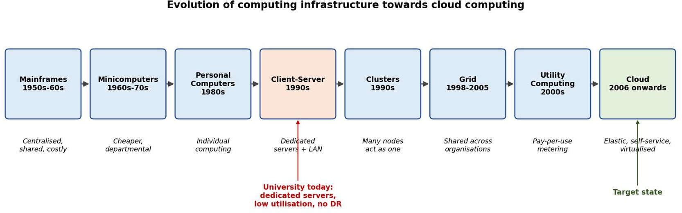
Task 2 – Trace the Evolution and Hardware Evolution

Timeline: from mainframes to cloud computing

Stage | Idea | Problem it solved / left
Mainframes | One big central computer | Very costly; led to time-sharing
Minicomputers, PCs | Cheaper machines for departments and individuals | Cost solved; data scattered
Client–server | Servers share data and apps on a LAN | Sharing solved; one app per server wastes capacity
Clusters, grid | Many machines work as one; resources shared between organisations | Power solved; hard to manage, no billing
Utility computing | Pay-per-use like electricity | Billing idea solved; needed virtualisation
Cloud | Virtualised, self-service, elastic, metered | Combines all of the above

Hardware that made the cloud possible
- Multi-core CPUs with virtualisation support (Intel VT-x, AMD-V), so many VMs run on one host.
- Cheap commodity servers that can be added in large numbers.
- Large, cheap and fast storage (HDD to SSD/NVMe, distributed storage).
- Fast networks (10/40/100 Gb Ethernet, fibre) and efficient large data centres.

Where is the university now?
At the client–server stage with dedicated servers: one application per physical server, a single data centre, servers bought for peak load, 15% average use, manual buying and no APIs or metering. These are exactly the limits that virtualisation and cloud remove.

Task 3 – Analyse Internet Software Evolution
Internet software moved from static web pages (read-only HTML) to the dynamic web (PHP/JSP with databases), then Web 2.0 (user content and AJAX for pages that update without reloading), then SOA and web services (reusable services with clear interfaces), mashups (combining several services in one app) and finally cloud-hosted applications (SaaS/PaaS delivered over the internet).
- Browser and HTTP: a universal client and a simple request/response protocol that works on any device.
- AJAX: the page asks the server for small pieces of JSON/XML, so the app feels fast like a desktop program.
- APIs: let mobile apps and other systems use our functions directly.
 | Desktop software | Client–server | Web / cloud
Install and update | On every PC, manual | Client + server | Nothing to install; central update
Access | One device | Mostly campus LAN | Anywhere
Scaling | None | Limited by server | Elastic
Integration | Poor | Proprietary | APIs
Cost | Licence per PC | Server CapEx | Subscription / pay per use
Effect on the university's design: split the monoliths into modules (login, results, fees, library), keep the web tier stateless so instances can be added freely, put static files on a CDN, and expose everything through versioned REST/SOAP APIs.
Task 4 – Apply Server Virtualization

Hypervisor
A hypervisor is software that splits one physical machine into several isolated virtual machines (VMs), each with its own OS. It shares out CPU, memory, storage and network and keeps the VMs apart.
- Type-1 (bare-metal): runs directly on the hardware, fast, used in data centres. Examples: VMware ESXi, Hyper-V, KVM, Xen.

- Type-2 (hosted): runs on top of a normal OS, good for labs and testing. Examples: VirtualBox, VMware Workstation.

Types of virtualisation
Type | How it works | Good / bad
Full | Hypervisor emulates the whole hardware; guest OS unchanged | Any OS works; some overhead
Para | Guest OS is modified to talk to the hypervisor | Faster; needs a modified OS
OS-level (containers) | Containers share the host kernel (Docker) | Very light and quick; weaker isolation
Hardware-assisted | CPU features (VT-x/AMD-V) handle privileged work | Near-native speed; needs modern CPU

What runs as VM and what as container
Application | Choice | Reason
SIS | VM | Old monolith with a database; critical data needs strong isolation, snapshots and live migration
Exam Portal | VM (containers later) | Monolith and security-critical; VM images can be cloned before exam weeks
LMS | Containers (web) + VM  (DB) | Web tier is stateless and scales out; database needs a VM
Library | Containers | Small app, easy to package
Email | VM | Stateful mail servers (later replaced by SaaS)

Consolidation calculation
Assumptions: all 12 servers have equal capacity C; average use 15%; target host use 70%; 10% virtualisation overhead; one extra host for HA (N+1); in the peak case 6 servers run at 95% together and the other 6 stay at 15%.
Average load = 12 x 15%
With overhead = 1.80 x 1.10
= 1.80 C
= 1.98 C
Case A: new host = 1 C (same as old server)
hosts = 1.98 / 0.70 = 2.83 -> 3, +1 for HA = 4 hosts Case B: new host = 3 C (modern server)
hosts = 1.98 / (3 x 0.70) = 0.94 -> 1, +1 for HA = 2 hosts

Peak load = (6 x 0.95) + (6 x 0.15) = 6.6 C; with overhead = 7.26 C
Case A: 7.26 / 0.70 = 10.4
Case B: 7.26 / 2.10 = 3.46
-> 11, +1 = 12 hosts
-> 4,
+1 = 5 hosts
Result: for the average load, 12 servers shrink to about 4 hosts (a 67% cut) or 2 modern hosts. Buying hosts for the peak would remove most of the saving, so the better plan is a small base plus cloud bursting for peaks. These are averages and assumed peaks, so real capacity must be checked with monitoring and load tests.

Benefits and risks
- Live migration moves running VMs between hosts with no downtime; snapshots give quick rollback; over-commitment (more vCPUs than cores, e.g. 3–4:1) works because average use is low.
- Risks: noisy neighbour (one VM hogs resources, fix with limits/reservations), hypervisor or host failure (fix with clustering and N+1), weaker isolation between VMs or containers (fix with patching, segmentation, separating sensitive systems).

Task 5 – Apply Web Services
A web service lets one program use another program's function over the network with standard protocols. In SOA and the cloud, services and APIs are how mobile apps, partner colleges and other systems connect to our applications.

Term | Meaning
SOAP | XML messages (envelope, header, body) over HTTP; strict contract, WS-Security, reliable, heavier
WSDL | XML file describing a SOAP service (operations, data types, endpoint)
UDDI | A registry to publish and find services (rarely used now)
REST | Resources as URLs with HTTP methods (GET, POST, PUT, DELETE), usually JSON; light, stateless, cacheable

University web services
Function | Endpoint | Method | SOAP or REST, and why
Result lookup | /api/v1/results/{regno} | GET | REST: read-only, cacheable, light JSON for mobile
Fee payment | /api/v1/fees/pay | POST | REST with OAuth2 token: easy for mobile and web; the call to the old bank system can use SOAP behind the scenes
Library search | /api/v1/library/search?q= | GET | REST: simple, high volume, cacheable
Transcript exchange with colleges | /ws/TranscriptService | POST | SOAP: formal WSDL contract and WS-Security between institutions
Sample requests and responses
GET /api/v1/results/21CS001
-> 200 OK {"regno":"21CS001","name":"Asha K","semester":5,"gpa":8.7}

POST /api/v1/fees/pay {"regno":"21CS001","amount":45000}
-> 201 Created {"status":"SUCCESS","receipt":"RCPT-0001","regno":"21CS001","amount":45000}

GET /api/v1/library/search?q=cloud
-> 200 OK {"query":"cloud","results":[{"id":1,"title":"Cloud Computing: Concepts...","available":true}]}

POST /ws/TranscriptService (SOAPAction: urn:GetTranscript)
<soap:Envelope xmlns:soap="http://schemas.xmlsoap.org/soap/envelope/" xmlns:u="http://university.edu/transcript">
<soap:Body><u:GetTranscript><u:RegNo>21CS001</u:RegNo></u:GetTranscript></soap:Body>
</soap:Envelope>
-> <u:GetTranscriptResponse><u:RegNo>21CS001</u:RegNo><u:GPA>8.7</u:GPA></u:GetTranscriptResponse>

Task 6 – Analyse the Service Models: IaaS, PaaS and SaaS

IaaS gives virtual servers, storage and network (we manage OS and above). PaaS gives a ready platform (we manage only our code and data). SaaS gives a finished application (the provider manages almost everything).

Layer | IaaS | PaaS | SaaS | On-premise
Application | We | We | Provider | We
Data | We | We | We (our own data) | We
Runtime / middleware | We | Provider | Provider | We
Operating system | We | Provider | Provider | We
Virtualisation, servers, storage, network | Provider | Provider | Provider | We

Mapping the five applications
Application | Model | Reasoning
SIS | PaaS | We own the business logic, so we keep the code but let the provider run the platform and managed database. This gives autoscaling and backups with no OS patching, and it can later be turned into APIs.
LMS | SaaS | A standard product (Moodle/Canvas type). Hosted SaaS scales by itself and gets upgrades for free; we only need plugins and branding.
Library | SaaS | Common function with low traffic; a hosted service avoids servers. The catalogue can be imported and exported.
Exam Portal | IaaS | Bursty and security-critical, may need special proctoring software and custom settings. IaaS gives control over OS and network and lets us clone pre-built VMs before exams.
Email | SaaS | A commodity service. Microsoft 365 or Google Workspace for Education gives high availability and spam protection that is costly to run ourselves.
Simple rule used: SaaS for common functions, PaaS where we own the logic but not the servers, IaaS only where special control is needed.
 | IaaS | PaaS | SaaS
Control | High | Medium | Low

 | IaaS | PaaS | SaaS
Cost | VM bills + admin cost | Moderate | Per-user subscription
Scalability | Scripted autoscaling | Built-in | Provider handles
Maintenance | High (OS, patches) | Low–medium | Minimal
Lock-in | Low–medium | Medium–high | High
Provider example | Amazon EC2, Azure VMs | Azure App Service, Google App Engine | Microsoft 365, Google Workspace

Task 7 – Examine XaaS
XaaS (Anything-as-a-Service) means any IT capability is delivered over the network on demand and billed by use, not only servers, platforms and software.
- DaaS (Desktop): virtual desktops for labs and remote students.
- MBaaS (Mobile Backend): ready login, storage and push notifications for the mobile app.
- FaaS (Function): small event-driven functions billed per run, e.g. receipts and notifications.
- DBaaS (Database): managed database with backup, patching, replication and scaling.
- SECaaS (Security): managed identity, firewall (WAF), DDoS protection.
- DRaaS (Disaster Recovery): continuous copy of systems in the provider's cloud with quick failover.

My two choices
- DBaaS: SIS and exam data are the most valuable data. DBaaS gives automatic backups, multi-zone failover and read replicas without needing specialist DBAs, which supports the availability target.
- DRaaS: the university has no DR site. Building a second data centre is costly, while DRaaS gives replication and failover mostly pay-when-used.

Risks of too many "as-a-Service" providers
Vendor lock-in, harder integration between providers, different security rules, an availability chain (the system is only as strong as its weakest service), subscription cost sprawl, privacy and data-location issues, and the risk of a provider shutting down a service. To reduce this: use open standards, keep exportable data and an exit plan, set up central cost and security governance, and read SLAs before signing.

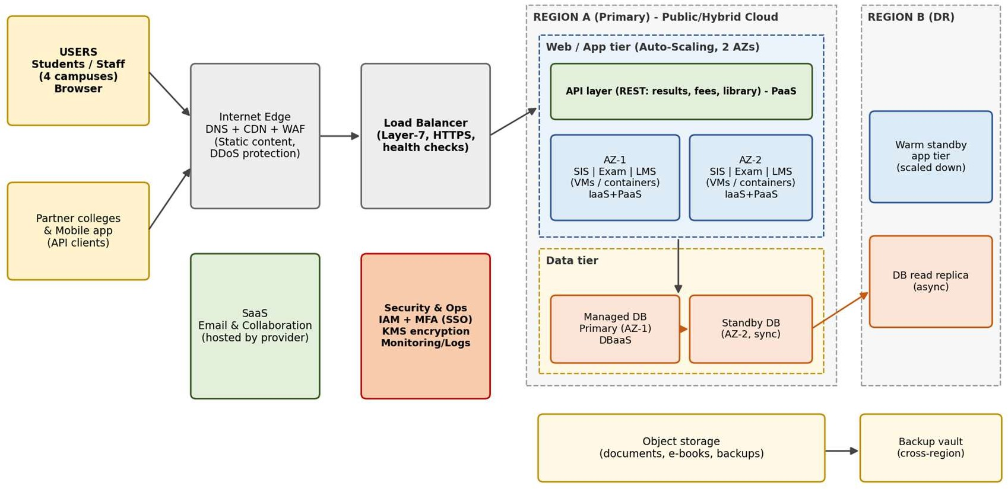
Task 8 – Design the Cloud Solution Architecture

Proposed architecture: multi-zone application, managed database and a DR region

Component | Model | Why
DNS + CDN + WAF | Public cloud, SECaaS | Caches static files, absorbs peaks, blocks attacks
Load balancer | Public cloud, managed | Shares traffic over zones, health checks, TLS
API layer | PaaS | One controlled door for web, mobile and partners (login, throttling, versions)
SIS / Exam Portal | PaaS / IaaS | Business logic in autoscaling groups across two zones
LMS, Library, Email | SaaS | Run by the provider, connected by single sign-on
Database | DBaaS | Primary and standby in different zones with automatic failover
Object storage | Public cloud | Documents, e-books, backups; encrypted
DR region | DRaaS | Replica database, small standby app tier, backups in another region
Unmigrated systems | Private (hybrid) | Stay on the virtualised hosts and connect by VPN

Elasticity for admissions and exam peaks
- Auto-scaling adds instances when CPU is above about 60% and removes them slowly when load drops.
- Scheduled scaling pre-warms capacity before admission dates, result publication and exam weeks.
- CDN and cache serve repeated reads (result pages); read replicas help the database.

Security and availability
- Access: single sign-on with MFA, role-based access (student, staff, admin), least privilege, audit logs.
- Encryption: TLS for data in transit, AES-256 at rest, keys in a key management service.
- Network: private subnets for app and database, security groups, WAF.
- Backup and DR: daily backups with point-in-time recovery and cross-region copies; target RPO about 15 minutes and RTO about 2 hours.
- Availability: two or more zones, health checks, automatic replacement of failed instances.

Task 9 – Hands-on Implementation and Documentation
What I built: a small Flask REST API (result lookup, library search, fee payment, health check) packaged in a Docker container and deployed to a PaaS with a managed database. Tools: Python 3, Flask, Gunicorn, Docker (python:3.12-slim), curl/Postman.

Code
from flask import Flask, jsonify, request, abort app = Flask( name )
# In-memory sample data (a managed DB such as RDS/Azure SQL replaces this in production) RESULTS = {
"21CS001": {"name": "Asha K", "semester": 5, "gpa": 8.7},
"21CS002": {"name": "Ravi M", "semester": 5, "gpa": 7.9},
}
BOOKS = [
{"id": 1, "title": "Cloud Computing: Concepts, Technology and Architecture", "available": True},
{"id": 2, "title": "Distributed Systems", "available": False},
]

@app.route("/health") def health():
return jsonify(status="UP")

@app.route("/api/v1/results/<regno>", methods=["GET"]) def get_result(regno):
rec = RESULTS.get(regno.upper()) if rec is None:
return jsonify(error="Student not found", regno=regno), 404 return jsonify(regno=regno.upper(), **rec), 200

@app.route("/api/v1/library/search", methods=["GET"]) def search_books():
q = request.args.get("q", "").lower()
return jsonify(query=q, results=[b for b in BOOKS if q in b["title"].lower()]), 200

@app.route("/api/v1/fees/pay", methods=["POST"]) def pay_fee():
data = request.get_json(silent=True) or {}
if not data.get("regno") or not data.get("amount"):
return jsonify(error="regno and amount are required"), 400
return jsonify(status="SUCCESS", receipt="RCPT-0001", regno=data["regno"], amount=data["amount"]), 201

if name == " main ": app.run(host="0.0.0.0", port=5000)
# requirements.txt flask==3.0.3 gunicorn==22.0.0

# Dockerfile
FROM python:3.12-slim WORKDIR /app
COPY requirements.txt .
RUN pip install --no-cache-dir -r requirements.txt COPY app.py .
EXPOSE 5000
CMD ["gunicorn", "-b", "0.0.0.0:5000", "app:app"]

Steps
- Put app.py, requirements.txt and Dockerfile in one folder.
- Build the image: docker build -t univ-api:1.0 .
- Run the container: docker run -d --name univ-api -p 5000:5000 univ-api:1.0
- Check it: docker ps, docker logs univ-api, and curl http://localhost:5000/health
- Test the success case (200) and the failure case (404) with curl or Postman.
- Deploy to a PaaS: push the folder to GitHub, create a Web Service from the repo (Docker runtime, port 5000), and add the managed database URL as an environment variable (never in the code).

Screenshots

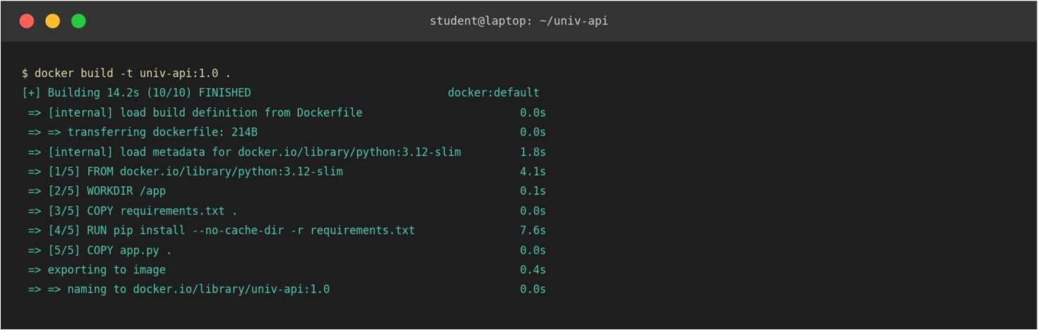
Docker build

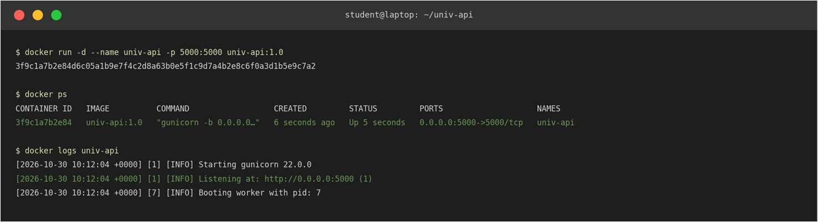
Container running (docker run, docker ps, docker logs)

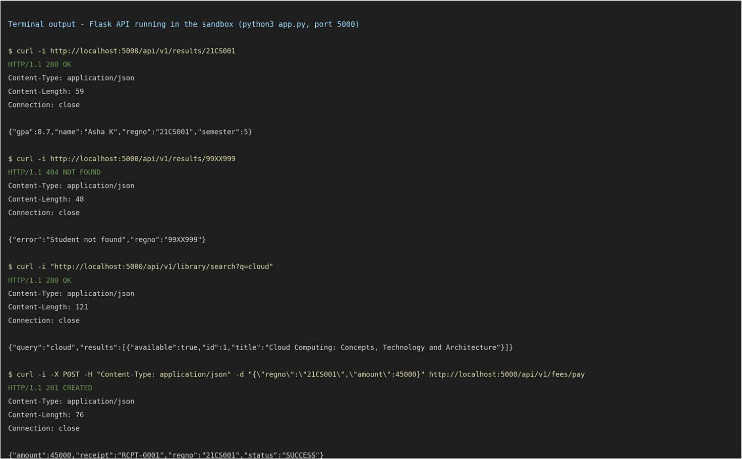
API tests with curl (200 for a valid student, 404 for an unknown one, library search and fee payment)

Browser check of the working endpoint
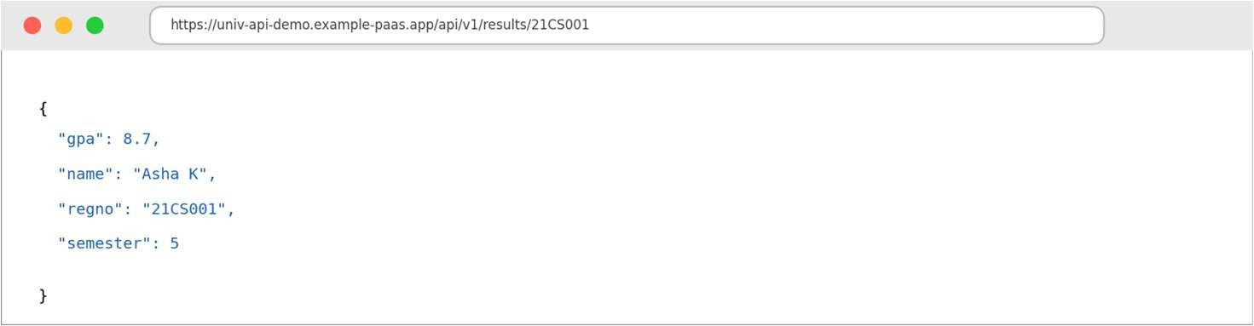

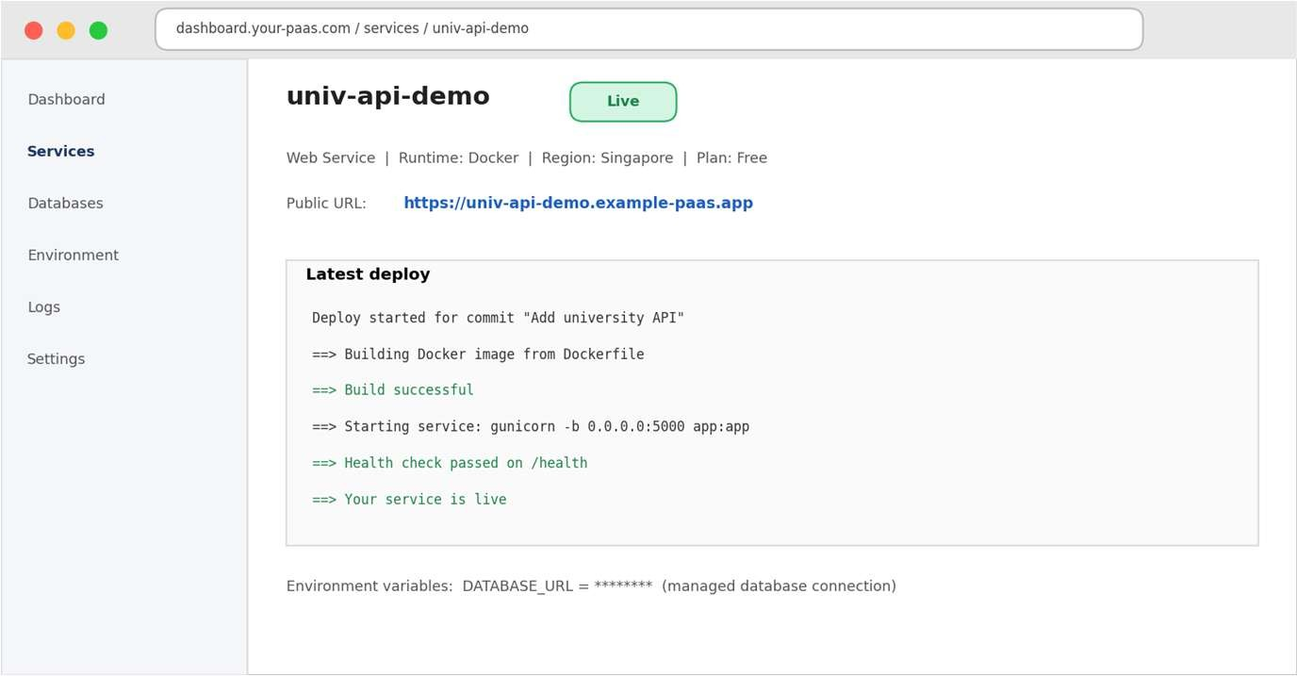
PaaS dashboard showing the live service and its public URL
Test | Result
GET /api/v1/results/21CS001 | 200 OK with JSON (gpa 8.7)
GET /api/v1/results/99XX999 | 404 NOT FOUND with error message
GET  /api/v1/library/search?q=cloud | 200 OK, 1 book found
POST /api/v1/fees/pay | 201 CREATED, receipt RCPT-0001

Issues faced and fixes
  - Port not reachable: bind to 0.0.0.0 and publish the port with -p 5000:5000.
  - Flask dev server is not for production: used Gunicorn in the Dockerfile.
  - Data is in memory and lost on restart: use a managed database for real use.

  - PaaS free tier sleeps when idle: the first request is slow (cold start).

Task 10 – Evaluate and Recommend the Final Solution

 | A. On-premise | B. IaaS (lift-and-shift) | C. PaaS/SaaS (chosen)
Cost type | High CapEx, fixed OpEx | OpEx, VMs billed 24x7 | OpEx, pay per use/user
Scalability | Fixed; 6–8 weeks to add | Good but needs scripting | Excellent, automatic
Availability | Single site unless 2nd DC built | Multi-zone, self-managed | Built-in multi-zone with SLA
Security | Full control and full duty | Shared; OS and apps are ours | Provider secures platform; we manage identity and data
Effort | Highest | High | Lowest
Three-year cost (₹ lakh, estimates)
Assumptions: current load; servers ₹4 lakh each; email is free for students under education plans, with paid licences for 2,000 staff at about ₹400/user/month; cloud prices include reserved-capacity discounts; PaaS/SaaS needs fewer administrators. These are estimates to replace with real quotations.

Item | A. On-premise | B. IaaS | C. PaaS/SaaS
One-time: servers 48 + storage/network 20 + DR site 35 | 103 | – | –
One-time: migration and training | – | 15 | 20
Per year: power/cooling/space 12 + AMC 8 | 20 | – | –
Per year: cloud bill (C: email 10, LMS 12, SIS/Exam/Library + DB 22, DR/CDN/monitoring 6) | – | 61.6 | 50
Per year: operations staff | 24 | 24 | 12
Per year total | 44 | 85.6 | 62
3-year total | 235 | ≈272 | 206
Option C is about 12% cheaper than on-premise and 24% cheaper than IaaS, and it also gives DR and elasticity. The on-premise figure covers only today's load.

Risks and fixes
Risk | Mitigation
Vendor lock-in | Use containers and open standards, export data regularly, keep an exit plan
Data privacy | Encryption, role-based access, audit logs, data-processing agreement, keep very sensitive data private/hybrid
Downtime in migration | Migrate in phases outside peak periods, keep rollback plans, multi-zone and DR
Skills gap | Training and certification, partner help at the start, templates and infrastructure-as-code
Cost overrun | Budgets and alerts, tagging, autoscaling limits, monthly review

Final recommendation and roadmap
I recommend option C: a hybrid, PaaS/SaaS-first solution with IaaS only for the Exam Portal, DBaaS for databases and DRaaS for recovery. It is the cheapest over three years, matches the peak-load problem, needs the least admin effort and finally gives us DR. The choice comes from the analysis in Tasks 1–8, not from a provider's popularity; any provider that meets the SLA, region, price, education offer and exit needs can be picked after a short trial and quotation comparison.

When | What moves | Why
Month 0–1 | Planning, network, single sign-on, training | Foundation for everything
Month 2 | Email to SaaS | Lowest risk, no custom code, a quick win
Month 3–4 | Library and LMS to SaaS | Standard products; move outside exam periods
Month 5–8 | SIS to PaaS + DBaaS, expose APIs | Most critical; moved after the team has experience, run in parallel first
Month 8–10 | Exam Portal, load tests, DR drill | Highest peak risk, so it moves last after full testing

When | What moves | Why
Month 10–12 | Switch off old servers, tune costs | Removes double payment

Task 11 – Day-4 Design Challenge: Re-evaluate and Adapt
New requirement: mobile app + 40 affiliated colleges, 10x the current peak, 99.9% availability (about 8.76 hours of downtime a year) and a limited budget.

Impact analysis
Area | Before | Now
Users | Campus users and web | Plus 40 colleges and mobile users, 24x7
Load | Seasonal peaks | 10x the peak, more continuous
Availability | Best effort | 99.9%, because fees are paid online
Cost | Moderate budget | Limited; cost must be shared with colleges
  - APIs become critical: the app and the colleges use the system only through APIs, so the API layer is now the front door and needs authentication, versioning, throttling, monitoring and high availability.
  - Multi-tenancy: each college must see only its own data. Risks are data leaking between colleges, one college slowing others, and one hacked account affecting many. Controls: tenant-aware login tokens (OAuth2 with a tenant_id), row-level security or separate schemas, per-tenant encryption keys, rate limits, and per-tenant audit logs.

Evaluation of the original design
  - 10x load: SaaS parts scale on the provider side, but the SIS on a fixed PaaS plan and the Exam Portal on VMs with manual scaling would not reliably cope; VMs take minutes to start and a monolith can only be cloned as a whole.
  - 99.9% availability: serial components in one zone are not enough:
Single zone: LB 99.99% x App 99.9% x DB 99.9% = 0.9979 -> 99.79%
downtime = 0.0021 x 8760 h = about 18.4 h/year (fails 8.76 h)

Multi-zone: LB 99.99% x App in 2 zones (1 - 0.001^2 = 99.9999%) x managed multi-zone DB 99.95%
= 0.9994 -> 99.94%
downtime = 0.0006 x 8760 h = about 5.3 h/year (meets 8.76 h)
  - Cost: keeping the old design but sized for 10x all year would multiply the ₹34 lakh/year compute + database part by 10 (about ₹3.4 crore/year), mostly idle. On-premise at 10x needs several crores of hardware. Neither fits a limited budget.
  - Better options: serverless (FaaS) for spiky jobs, MBaaS for the mobile backend, managed API gateway, queues and caching.

Decision: MODIFY the design
The cloud-first, PaaS/SaaS, DBaaS and DR direction stays, so a full redesign is not needed. The changes make it API-first, container-based, partly serverless and spread over three zones.

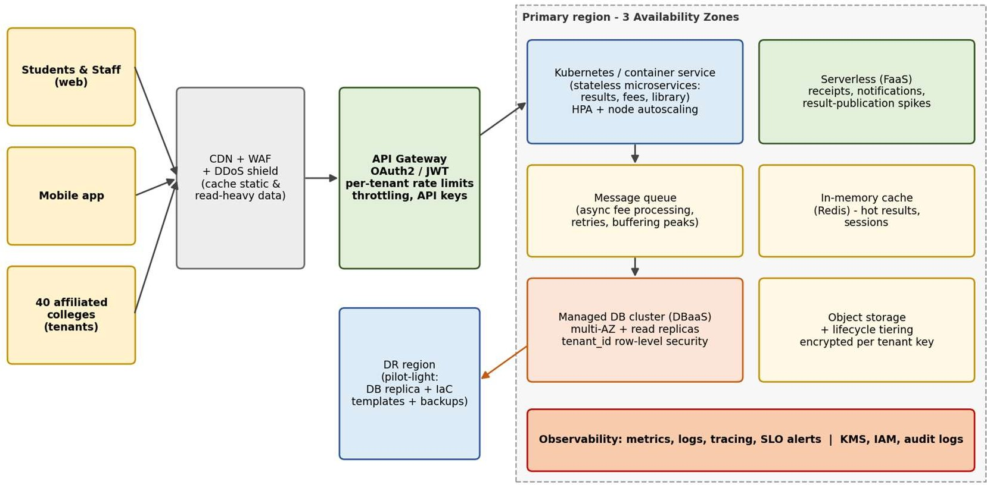

Modified architecture for the mobile app, 40 colleges, 10x load and 99.9% availability

Area | Original | Modified
Front door | Load balancer | CDN + WAF + API gateway with OAuth2 and per-tenant limits
SIS / fees / results | VMs or fixed PaaS | Containers on a managed container service with autoscaling
Spiky jobs | Main application | Serverless functions and a message queue
Mobile backend | None | MBaaS (login, push notifications)
Database | DBaaS primary + standby | Multi-zone DBaaS + read replicas + cache, row-level tenant security
Zones / DR | 2 zones, DR region | 3 zones, DR region in pilot-light mode
Virtualisation | VMs | Containers; VMs only for legacy parts

Evidence-based defence
Capacity (assumed: current peak 500 requests/s; one container handles 100 requests/s at 70% load):
New peak = 10 x 500 = 5,000 requests/s
Containers = 5,000 / 100 = 50; must survive loss of 1 of 3 zones: 50 / (2/3) = 75 -> use 80 With 80% cache hits and 90% reads: DB reads = 5,000 x 0.9 x 0.2 = 900/s, writes = 500/s
-> multi-zone primary + 2 read replicas; queue absorbs fee-payment bursts
The 80 containers run only at peak; off-peak about 15–20 run, so cost grows far less than 10x.
Cost per year (₹ lakh, estimate) | Original (1x) | Modified (10x) | Note
Compute (PaaS / containers / functions) | 22 | 30 | Autoscaling
Database (DBaaS) | 12 | 22 | Multi-zone + replicas
CDN, WAF, API gateway | 3 | 12 | Pay per request
Storage, backup, DR | 3 | 8 | Pilot-light DR
SaaS licences, monitoring, security | 10 | 10 | About the same
Operations staff | 12 | 16 | Automation
Total | 62 | 98 | About 1.6x for 10x load
  - 3-year view: 3 x 98 + 12 (extra engineering) = ₹306 lakh, against about ₹3.4 crore per year for a static 10x original. Shared among 40 colleges it is about ₹2.45 lakh per college per year, plus a small fee per payment, so the service can pay for itself.
  - Security: tenant-aware tokens at the gateway, row-level security, per-tenant keys and quotas, WAF and DDoS protection, per-tenant audit logs, privacy agreements and regular penetration tests.

  - Trade-offs: more lock-in with managed services (reduce with containers and OpenAPI contracts), more complexity (reduce with managed services and training), migration effort (move only fee, result and student-record services first, leave the rest), and cost control (budgets and quotas).
Conclusion: the modified design handles 10x load by autoscaling, reaches about 99.94% availability (about 5.3 hours downtime a year), isolates the 40 colleges and costs about 1.6x the original, which makes it the best choice for a limited budget.

